**INSTRUCTIONS:**

**We are trying to understand more about how people with autism, or autistic tendencies, and people without autism search the web.**

* **For the search queries below please indicate what search terms you would use to search the web.**
* **There are no right or wrong answers.**
* **Some of the searches do not have an answer but please tell us how you would go about trying to search for the answer.**
* **If you would do many iterations of search, please indicate that below. Start with the one you are most likely to try.**
* **Please indicate as much as you can about your search process as possible. Use as much space as you need.**

**The second part asks you to complete an online questionnaire and report back the score on this sheet.**

**If you have any questions you can contact e.massand@bbk.ac.uk.**

EXAMPLE QUESTION:

You saw a man reading the paper today (you don’t know which paper it was), and the headline was vaguely about a new discovery about the solar system. What would you type into search on your favourite search engine to find out about the story?

EXAMPLE ANSWER:

*I could start by searching, ‘solar system and discovery and news and today’.*

*If that doesn’t work I could search, ‘todays paper and solar system’, or if I don’t find my answer there I could search ‘news’ and manually /visually sift the page for relevant info.*

What browser (Google Chrome, Firefox, Safari, …), and search engine (Google, Yahoo, Bing …) are you using to complete this task?

Browser: Google Chrome

Search Engine: Google

1. You hear a song on the radio with the lyrics, ”Look at your children”, and you want to download it. What would you type into search on your favourite search engine to find out what song it was?

Search: “Look at your children song”

1. To find out about todays trending news stories, what search terms would you use?

Search: “news”

1. To find out if it will rain tomorrow, what search terms/ queries would you use?

Search: “BBC weather” or “Weather in HA3”

1. You’ve lost touch with an old school friend (you went to St. Mary’s School). What key words/queries would you use to find them?

Search: “St Mary’s their name year of 2005 students”

1. How would you identify what this is using a search engine (pretend you don’t know what it is called). What key words/queries would you use?

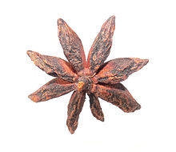

Search: “Star shaped natural/organic ingredient”

(Assuming this was in front of me I would know it was an ingredient.)

7. How would you find out the name of this famous person using a search engine? What key words/queries would you use?



Search: “top famous young women” (and then sift through)

Would also try “most talked about famous women”

8. Your friend and you can’t agree on how *Thandie Newton* pronounces her first name. How would you resolve this using a search engine?

Search: “Thandie Newton name”

Would also search for her on Youtube to see how interviewers pronounce her name.

9. How would you identify what breed this animal is using a search engine? What key words/queries would you use?

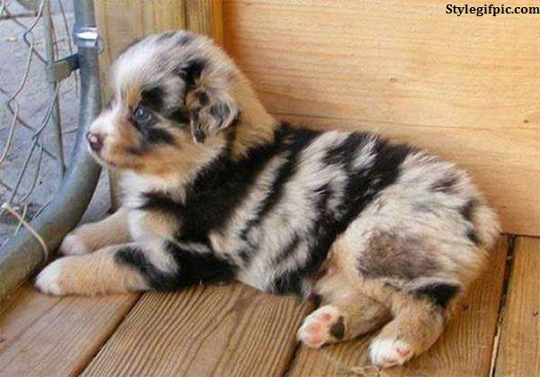

Search: “black striped dog breeds” and sift

10. What would you search for to identify this pattern’s *name*, and which *country* it originates from?

Search: “repeating square maze pattern” and then “repeating square pattern name”

11. How would you search for delay’s relating to your (imminent) flight to Paris?

Search: “Flight number”

**Part 2.**

<http://aspergerstest.net/aq-test/>

Go to the link above and report back your score on the Autism Quotient. There are 2 formats, please take ‘AQ Quiz Option 1’.

Your score here: 22